

HH UHC Reporting Requirements
Created by: Brian Conley | Created on: 4/23/25 | Edited: 6/23/25

This is a requirements document created through collaboration with the Home Health leadership team and Enterprise Analytics. The metrics and documentation here are to be used for UHC Reporting. The metrics are broken out into 2 phases and documented as such.
This file seeks to combine the requirements that have been documented in Excel and Word to consolidate. The original file links can be found here:
Excel: UHC Measures.xlsx
Word: UHC Requirements Refinement.docx

Data Details
Sources:
- BSHHomeHealthHospice
  - Queries creating a few facts such as factTaskProductivity and factM0Item
New Requirement Clarifications:
- Visits in Status of RESCHEDULED, OFFICE REASSIGNED or DECLINED status should be included in counts of ‘In Home Visits’ that would count in the visits denominator for metrics like Missed Visit and VPE (Visits Per Episode).
- Open Metrics of VPE and LUPA should include visits in the following statuses:
  - COMPLETED, MISSED, RESCHEDULED, OFFICE REASSIGNED, DECLINED, and orders in a REQUESTED status (Ordered but not Scheduled)
  - Closed Metrics of VPE and LUPA should only included COMPLETED visits for these metrics
- Exclude “-PRN” service codes in ANY STATUS other than COMPLETED or MISSED from all metrics (OPEN or CLOSED) –need to add to the table metrics bc 6/25/25
- Added new Insurance type of ‘COMMERCIAL INSURANCE-EPISODIC/RATE CASE’ to the logic as an episodic payor type
- Add to Phase 2: VPP (Visits per Billing Period) by Clinical Grouping

To Do

Phase 1 Metrics
Metric | Metric Description | Denominator | Numerator | Sample/Validation Report
TTL VPE - Open | Total # visits per open episode | denominator is the count of distinct episodes BEGINNING within the selected time frame. | Numerator is number of ANY billable visits IN THOSE BEGINNING EPISODES (COMPLETED, MISSED, RESCHEDULED, OFFICE REASSIGNED, DECLINED, and orders in a REQUESTED status (Ordered but not Scheduled)) | Scheduling requests report in Report manager
By Discipline VPE - Open | Service Code starting with SN/PT/OT/ST/HHA/MSW - OPEN is the high priority | denominator is the count of distinct episodes BEGINNING within the same time frame. When broken into disciplines, the denominator includes only episodes that have at least 1 task of that discipline type. | Numerator is number of ANY billable visits of the discipline IN THOSE BEGINNING EPISODES (COMPLETED, MISSED, RESCHEDULED, OFFICE REASSIGNED, DECLINED, and orders in a REQUESTED status (Ordered but not Scheduled)) | Scheduling requests report in Report manager
TTL VPE - Closed | Total visits per closed episode | denominator is the count of distinct episodes ENDING within the selected time frame. | Numerator is number of COMPLETED billable visits IN THOSE ENDING EPISODES
By Discipline VPE - Closed | Service Code starting with SN/PT/OT/ST/HHA/MSW | denominator is the count of distinct episodes ENDING within the same time frame. When broken into disciplines, the denominator includes only episodes that have at least 1 task of that discipline type. | Numerator is number of COMPLETED billable visits IN THOSE ENDING EPISODES (of that discipline type)
LUPA 1st/2nd BP - Open | Count of BILLING PERIODS BEGINNING where eligible visits (billable) (COMPLETED, MISSED, RESCHEDULED, OFFICE REASSIGNED, DECLINED, and orders in a REQUESTED status (Ordered but not Scheduled)) (respectively) is less than the designated LUPA threshold | Denominator is the count of billing periods BEGINNING in the designated time frame. Both numerator and denominator exclude records where zero billable visits are ordered/scheduled. | Numerator is the count of billing periods where the number of billable visits (COMPLETED, MISSED, RESCHEDULED, OFFICE REASSIGNED, DECLINED, and orders in a REQUESTED status (Ordered but not Scheduled)) - SN, PT, OT, ST, HHA, or MSW) is less than the established LUPA Threshold value for that BP BEGINNING.
TTL LUPA - Open | Count of BILLING PERIODS BEGINNING where eligible visits (billable) (COMPLETED, MISSED, RESCHEDULED, OFFICE REASSIGNED, DECLINED, and orders in a REQUESTED status (Ordered but not Scheduled)) (respectively) is less than the designated LUPA thresholdthreshold
LUPA 1st/2nd BP - Closed | Count of ENDING BILLING PERIODS eligible visits (billable COMPLETED) in the 1st/2nd billing period (respectively) is less than the designated LUPA threshold | Denominator is the count of billing periods ENDING in the designated time frame. Both numerator and denominator exclude records where zero billable visits are COMPLETED. | Numerator is the count of billing periods where the number of billable visits (COMPLETED - SN, PT, OT, ST, HHA, or MSW) is less than the established LUPA Threshold value for that BP ENDING.
TTL LUPA - Closed | Count of BILLING PERIODS ENDING where eligible visits (billable COMPLETED) in the 1st OR 2nd billing period is less than the designated LUPA threshold |  |  | PDGM outlier report
Ghost BP - Open | 0 billable visits in billing period BEGINNING (aka Lost/Ghost) | all billing periods BEGINNING in timeframe | billing periods BEGINNING with 0 billable (COMPLETED, MISSED, RESCHEDULED, OFFICE REASSIGNED, DECLINED, and orders in a REQUESTED status (Ordered but not Scheduled))) visits | PDGM outlier report
Ghost BP - Closed | 0 billable visits in billing period ENDING (aka Lost/Ghost) | all billing periods ENDING in timeframe | billing periods ENDING with 0 billable (COMPLETED) visits | PDGM outlier report
MV | "IN HOME VISITS': BILLABLE SERVICE CODE VISITS  MISSED VISITS: Count of BILLABLE SERVICE CODE visits where status ='MISSED' AND VisitMissedReason in  'MEDICAL TREATMENT ONLY','TRANSITION RECERT',  'NON-ADMIT','OASIS DATA COLLECTION ONLY'" | BILLABLE SERVICE CODE Evisits in 'COMPLETED' status (does not include Non Visit Discharges - NVDC, service codes containing *66*) +MISSED VISITS (defined in logic) | Missed Visits as defined in metric description
30 day HH Hospitalization | "1. Denominator: Count of admissions (M0100 ='01') for month where 30 days have passed from end of month.  i. SOC OASIS must be in any status except: ""Not Started"", ""Not Yet Due"", ""Deleted"", ""Missed Visit"", 'Saved"" and associated with an active episode  ii. Insurance: Medicare traditional only (M0150 = 1) at Start of Care SOC date (M0030)  iii. Date: SOC date (M0030) and 30 days from SOC have passed. *Report displays only those months where 30 days have passed from end of month (Closed months)  iv. First payment episode is not a LUPA (billable visit count >= LUPA Threshold)  v. Prior Inpatient facility was a short stay acute hospital (M1000 =1)  vi. Inpatient DC date (M1005) is within 5 days prior to HH SOC (M0030)  2. Numerator: denominator population that have transfers (M0100 in (07,09) within 30 days of SOC (M0906 - M0030)  i. Facility type is hospital (M2410 = '01')  ii. Reason for Hospitalization was not Planned/Scheduled (is not 19 on OASIS form, or M2430 != 1)  iii. Hospitalization Counts: 1st hospitalization per admission (“sequence” or admission)  " | Denominator: Count of admissions (M0100 ='01') for month where 30 days have passed from end of month. | Numerator: denominator population that have transfers (M0100 in (07,09) within 30 days of SOC (M0906 - M0030)
Non Visit Discharges | "Non Visit Discharges: Count of completed visits with s service code containing *66*  Non Visit Discharges %: NVDC count/total completed Discharge visits (defined as visits where VisitType='DISCHARGE')" | total completed Discharge visits (defined as visits where VisitType='DISCHARGE') | Non Visit Discharges: Count of completed visits with service code containing *66*
% of HH episodes ACH (PPH?) | "1. Denominator: Count of ‘ending’ assessments - transfers/discharges M0100 in ('06','07','09')  i. Transfer/Discharge OASIS must be in any status except: ""Not Started"", ""Not Yet Due"", ""Deleted"", ""Missed Visit"", “Saved"" and associated with an active episode  ii. Insurance type: M0150 = 1,2,3,4 (“Medi-medi payers”) at transfer  iii. Date: transfer date/discharge date (M0906)  2. Numerator: from denominator population, count all transfers to hospital (M2410 = '01') where the Reason for Hospitalization is not 19 or “Planned/Scheduled” (M2430 != 1)  " | Denominator: All ‘ending’ assessments - transfers/discharges (M0100 in ('06','07','09') - medi-medi payers | Numerator: all transfers to hospital (M2410) - Medi-Medi payers (where the Reason for Hospitalization is not 19 or “Planned/Scheduled” (M2430 != 1)) | Note that the Power BI Hospitalization reports use M code logic, not claims. If we need to use claims, we will have to rebuild these

Phase 2 Metrics
Metric | Data logic applied | Denominator | Numerator | Validation/Sample Report
TIOC | Compares referral date and SOC visit date (SOC OASIS questions) <48 hrs to be considered timely. Phys ordered have to be same day. Measured MTD  b. OASIS Code Physician Ordered = M0102  c. OASIS Code Referral Date = M0104 | All SOC | All SOC where referral/SOC <48 hrs
Timely Sync | All PCC visits should sync to HCHB within same as visit date or by 9 am next day (see date per visit - LAWT to send screenshot of date/timestamp) - compare to M0030 date (SOC) - other visit types in later iterations (Research finding the last updated date) | SOCs visits | SOCs visits synced within criteria | Open event items (Report manager)/Screens. Visit Sync time anaysis report
Dx Grouping | Clinical grouping (should fall into one of the 12 for UHC program). Primary Dx per patient (at SOC and Recert) (Need billing periods) | All SOC/Recert Visits - should this be count of Billing periods since clinical grouping is assigned at the BP level? Ending/beginning? | SOC/Recert visits associated with designated clinical grouping | Clinical input - Primary Diagnosis Field, Referral  Clinical Input on Diagnosis Tab - PDGM utilization report should have clinical group, patients by diagnosis report
Reimbursement | $ amount in contract  Early = If within the first billing period (30 days)  Late = Anything beyond the first 30 days  an "early" 30-day billing period refers to the first 30-day period of a new episode of care, while a "late" period is any subsequent 30-day period within that episode  billing period BEGINNING or ENDING date to be used? | na | na
DME | Durable Medical Equipment (on plan of care) has vs needs (OASIS question) | # of Needs - on what date? OASIS Assessment Date? | # Has
Wounds | SOC/Recert OASIS (does this patient have a wound/pressure ulcer, surgical wound) | ? | counts where M1306, 1330, 1340 = YES - on what date? OASIS Assessment Date? | Patients by diagnosis report
% of HH Episodes ED not admitted | Question to be added to HCHB - requires HCHB enhancement. Threshold 77  Should have data for all of May | All episodes - ENDING? | episodes where any visit has the new question answered 'yes'
% HH episodes with at least 1 clinician visit | clinician' visits = SN/PT discipline.  Confirm if date is episode ending | All episodes - ENDING? | Episode where at least 1 qualifying visit happens (Status = Completed and isBillable) | Agent visit report
% of HH Episodes with medication reconciliation | OASIS question (CC M2001) - SOC and, ROC and Recert | All episodes - ENDING? | M2001 is any version of YES
VPP (Visits per Billing Period) | VPP by Clinical Grouping

Metric Details and Screenshots

Agent Visits Report:
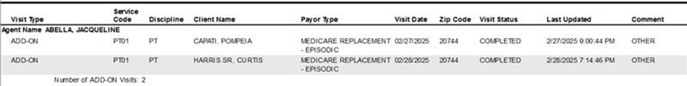
Clinical Grouping:
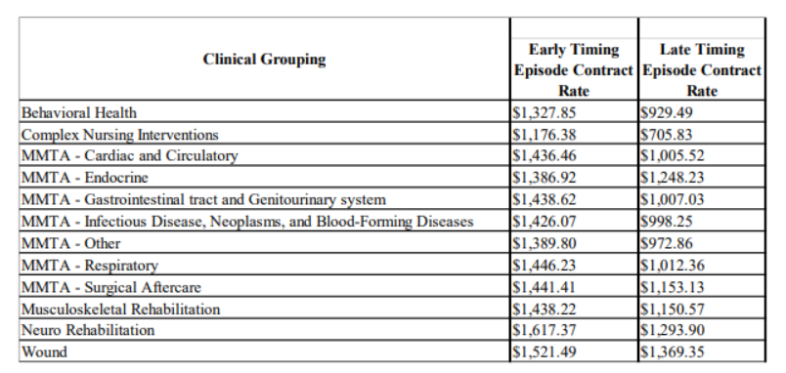
DME (Durable Medical Equipment):
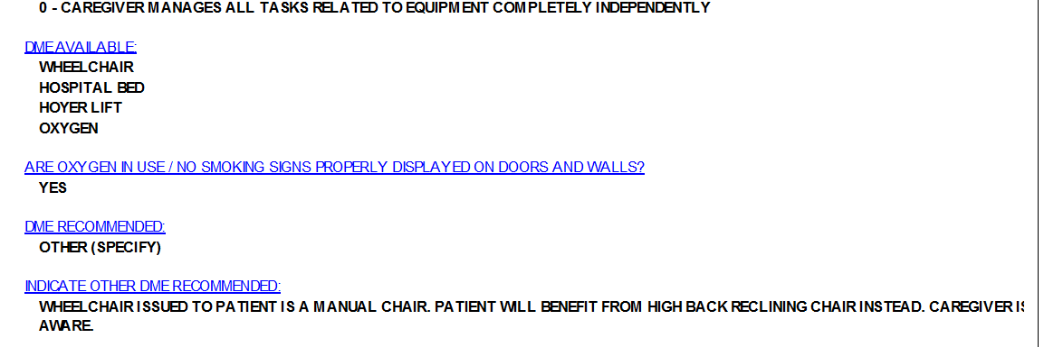

Wounds:
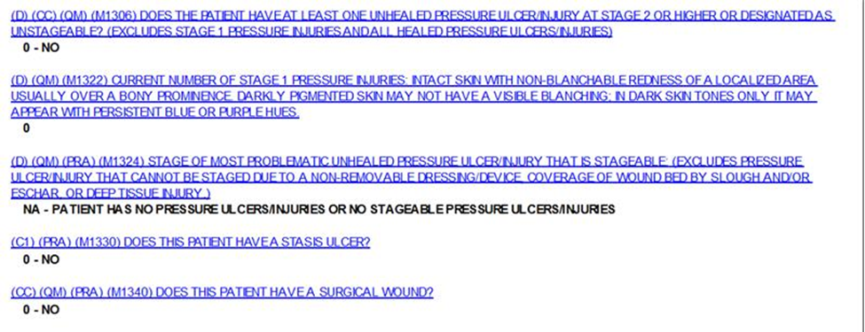
% HH Episodes with medication reconciliation:
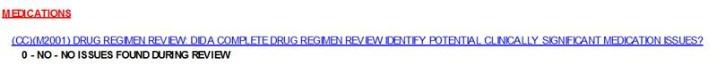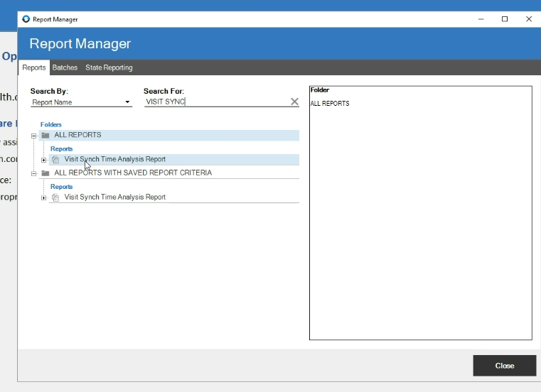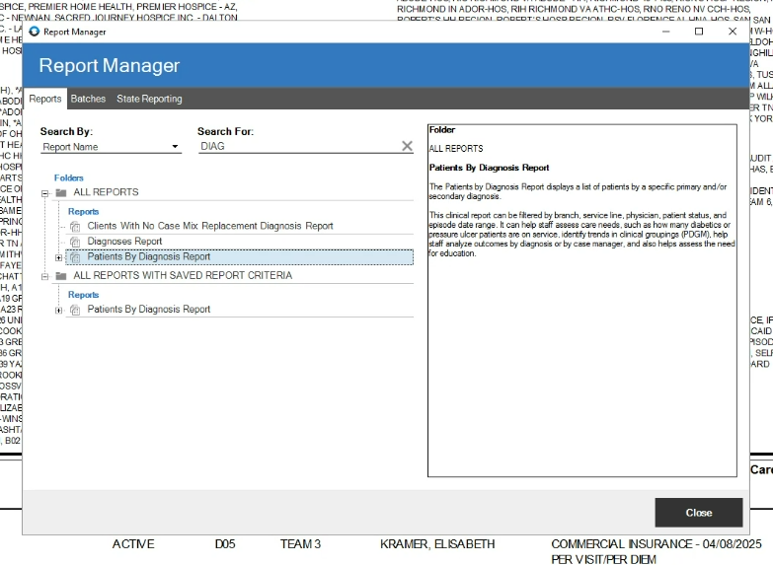

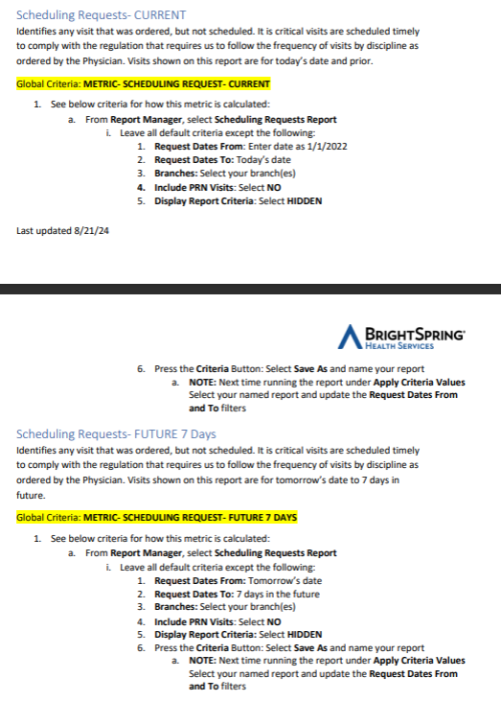
Analysis
DME

- Questions Available in dimQuestion
- Answer Available in dimAnswer
- Need clarification on Oasis Assessment date – Available Dates – From FactClientAssesments (Joins dimQuestion and dimAnswer ) – Assess Items Insert Date, Assess Items Updated Date, Visit Date
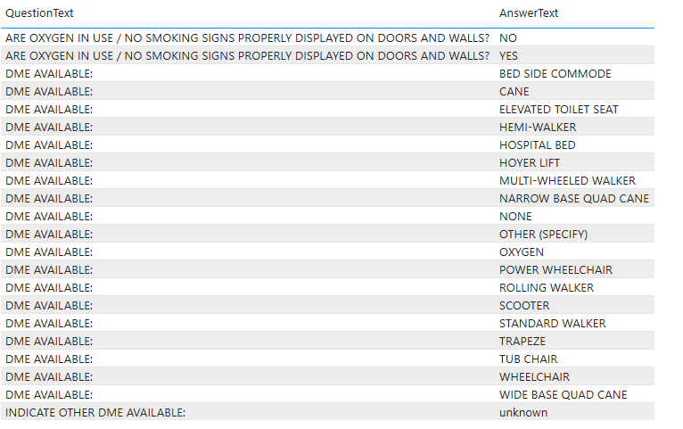
Wounds

- Questions Available in dimQuestion
- Answer Available in dimAnswer
- AssociatedMONumber – M1322, M1306, M1330, M1340
- SOC Date Available through FactClientAssessments
- Need clarification on Oasis Assessment Date
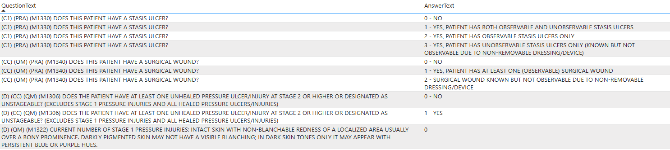
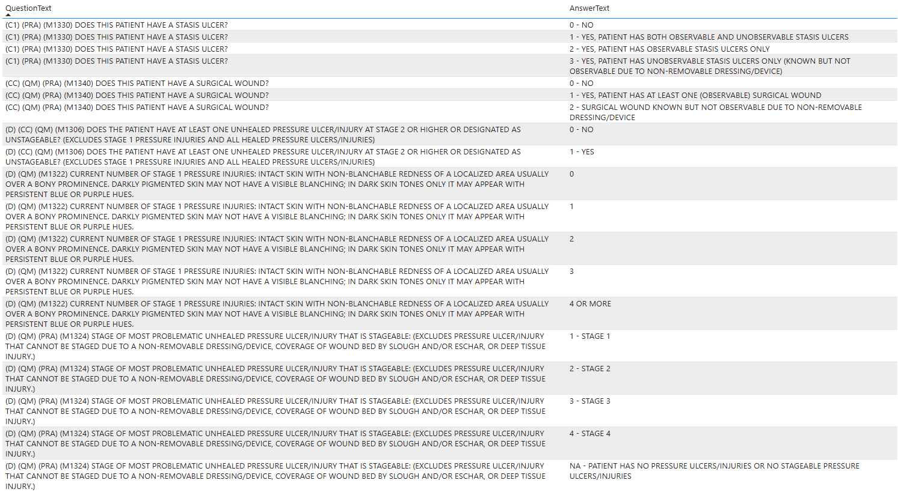
% of HH Episodes with medication reconciliation

- Questions Available in dimQuestion
- Answer Available in dimAnswer
- AssociatedMONumber – M2001
- SOC Date Available through FactClientAssessments
- Need clarification on Oasis Assessment Date
  - Note BC:
  - For an SOC (XX00) technically it is within 5 days of the visit date (when we touch the patient). M0090 is the date that the OASIS information is completed by the clinician (usually the visit date), whereas the M0030 is the SOC date - the first date we touch the patient. For the in-home OASIS visits like Recert (XX02 and XX15) the M0090 will be the visit date. For non-visit Transfer or Discharge OASISes (TIF / XX44; DC / XX66; DAH / XX88) the M0090 will be the recorded date of assessment, but they introduce a new variable: M0906. The M0906 is the date of "discharge, transfer or death," which will be same or earlier than the M0090.
- All Episodes – Ending? Is it a status or are we talking about the End of Episode Date?
